

Aberdare Town Church in Wales Primary School

God’s Word is the Best Learning
Gair Duw Gorau Dysg

Assessment, Recording and Reporting Policy

Agreed by Governors | Autumn
Date of Review | 2026
Headteacher | C.B Walters
Chair of Governors | J Close

This policy was produced by the Head teacher in consultation with the staff. This policy is intended to help staff:
- Enable individual learners’ progress
- Enable and support effective teaching and learning
- Summarise and report the outcomes of teaching and learning
- Further develop understanding of assessment and its role within the educational process.
This policy provides a broad structure and covers a range of assessment related practices. However, it should not be viewed in isolation and is well supported by other curriculum documentation. The practical guidance on good practice has been adapted by the assessment coordinator to meet our school’s special circumstances and to reflect current developments in education. It sets high expectations for our staff and pupils.
Policy Making
The procedures and policy guidelines for assessment, recording and reporting are governed by agreed and understood principles which inform the action we take. In this context our policy:
- Takes account of national and local initiatives (Welsh Government/National Testing/Assessment/Standardisation and moderation processes/On Entry Assessment)
- Promotes pupil achievement through the processes of assessing, recording and reporting
- Is developed with reference to current curriculum thinking and planning recognizing and promoting best practice
- Complements the work of existing systems within the school.

Introduction
Every child has a right to an education that should help them fully develop their personalities, talents, and abilities (Article 28 & 29 UNCRC). All staff recognize the purpose of assessment is to support each individual learner to progress at an appropriate pace, ensuring they are supported and challenged accordingly. The focus is on identifying where the learner is in their learning, their next steps and the support or challenge needed to move forward in their learning.
In recent years, new issues have come to the fore, which have a direct impact on our assessment practices. These include:
- Curriculum for Wales Assessment
- Literacy/Numeracy Framework
- Digital Competency Framework
- On Entry Assessment
- Non Maintained Curriculum
- National Tests ( Reading, Numeracy reasoning and Numeracy Procedural)
- Use of Standardised Tests (Reading)
- Value added initiatives
- Tracking systems
- Target setting
- Whole school self evaluation and review
- ESTYN inspection
- Performance review School Improvement Officer, Governing Body, Local Authority and Headteacher
Together these make it essential that teachers and governors are aware of a range of purposes of assessment and the practical strategies through which assessment information can be used effectively.
We believe that assessment is part of a continuous process of school improvement. Where the processes are part of everyday practice within a school, the culture helps the staff and others to improve their practice on a daily basis, with the focus on pupils’ learning in the classroom.
At a whole school level, the cyclical process of planning, implementation and review must be established. Whole school self-evaluation is viewed as a means of both seeking improvement and recognizing success.
Progression in learning is how a learner develops and improves their skills and knowledge over time. This means increasing breadth and depth of knowledge, deepening understanding and refining skills, all whilst becoming more independent and applying knowledge to new situations. Progression is at the heart of Curriculum for \wales guidance. The Principles of Progression and Statements of What Matters guide curriculum and assessment design, with assessment arrangements and the Pedagogical Principles being an integral part of both.
The principles of progression provide mandatory requirement of what progression must look like for all our learners. They describe what it means for learners to progress, and the capacities and behaviours practitioners must seek to support, regardless of a learners’ stage of development.

Defining Good Assessment Practice
Assessment is a natural part of the teaching and learning process. It is concerned with acquiring, collecting, analyzing and evaluating information about pupils’ performance.
All staff agree that effective practice:
- Enables teachers to monitor pupil progress in lessons and over time throughout their school journey
- Informs teachers about their pupils learning requirements
- Supports teachers in enabling and encouraging pupils to maximise their abilities
- Enables pupils to demonstrate their achievement across the full range of curricular objectives
- Helps pupils understand what they need to do to improve

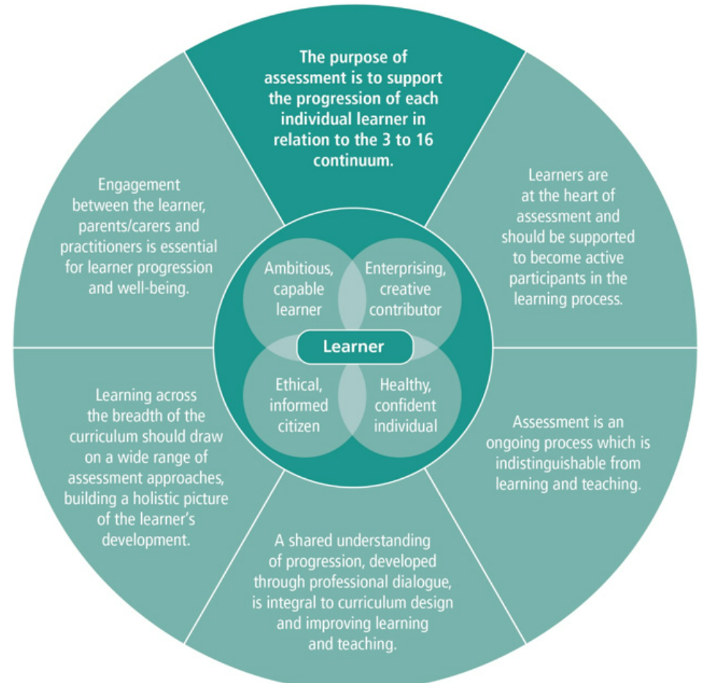
Fundamental Principles
Assessment, recording and reporting should:
- Support the progression of each individual learner throughout their time in school
- Be an ongoing process which is indistinguishable from learning and teaching
- Ensure that pupils are at the heart of assessment and should be supported to be participants in the learning process
- Draw on a wide range of assessment approaches building a holistic view of the learner’s development
- Be based on a considered and agreed view of what learning should be assessed in each area
- Offer all pupils, including those with additional needs, an opportunity to show what they know, and understanding what they can do
- Help pupils and teachers to identify the learning and teaching required to ensure a process of continuous development
- Help parents to be involved in their children’s’ progress
- Provide schools with information to evaluate work and set suitable targets for improvement

Purposes of Assessment
All staff agree that assessment has a number of important purposes.
- To support individual learners on an ongoing, day to day basis
- To identify, capture and reflect on individual learner progress over time
- To understand group progress in order to reflect on practice
Arrangements to asses pupils’ work aim to fulfill each of the above purposes. The prime purpose, however is to assist pupils in their learning by making informed judgements about what they know, understand and can do and what they need to do to progress.

Guidelines for Assessment for Learning
Formative Assessment
Formative assessment is about teachers and pupils using assessment information to modify their work in order to make it more effective. Good formative assessment is a powerful tool for raising standards of learning.
The continuum from 3 to 16 in Curriculum for Wales, helps to ensure a smoother learning journey for learners. Assessment is key to supporting each individual learner to make progress along the same continuum at an appropriate pace, ensuring that they are both supported and challenged to reach their potential.
Learners continue to build on prior learning throughout the academic year and this continues as they transition from year group to year group as the school’s curriculum is being developed to incorporate the progression outlined in the principles of progression. When planning and delivering learning experiences which have assessment embedded within, staff are aware of how they are contributing to a learners overall progress and identify how to tailor support ongoing support to effectively enable the learner to continue to progress.
Good formative assessment takes place when teachers know the standards and expectations of pupils appropriate to their age and to the statements of what matters and the principles of progression described in the Curriculum of Wales. Equally important is the degree to which teachers are able to make consistently accurate and reliable assessments of pupils’ achievements.
Agreed strategies:
- Design a shared understanding of Curriculum for Wales progression
- Agree marking standards prior to assessment
- Apply standard consistently
- Moderation at school level
- Ensure subsequent monitoring of how well school consistency is achieved

On Entry Initial Assessment
Baseline assessment is undertaken in the first six weeks of the child starting school. This enables teachers to plan activities which target specific needs. WELCOMM is undertaken on entry to Nursery. These are valuable tools for gaining an understanding of where a learner is in their learning and to help to identify their strengths, the next steps and the support needed to enable progress to be made. It all assists in identifying children that may have additional needs ensuring early support in given and providing a baseline against which progress and performance of pupils can be evaluated.

On Entry Assessment
Given the importance of progression under Curriculum for Wales when a child enters school from elsewhere, staff will assess where a learner is in regard to 3 -16 continuum. This will include:
- Numeracy and Literacy skills and capabilities
- Well-being abilities, to include physical, social and emotional development.
Staff will closely monitor pupils with ALN, to ensure progress is assessed and maintained. This will be achieved using diagnostic reading tests, Holbourne and Salford.

Summative Assessments
A range of summative assessments are used in addition to formative assessments.

Statutory Personalised Assessments
Personalised assessments in Reading and Numeracy for learners in Years 2 to 6 are statutory and available to take throughout the school year. The purpose of these assessments is to help support progression in reading and numeracy skills. After learners have completed these assessments, school has access to feedback on learners’ skills, progress, age-standarised scores, and a range of reports to help plan teaching and learning.
Information gathered through assessing individual learners will only be bused by practitioners and learners through the school. Information from Personalised assessments is used to provide feedback and ways forward for pupils and to assist in planning for staff. Progress reports for learners and their careers helps to inform next steps. Assessment information will be used by the school as part of an effective self-evaluation process, reflecting on approaches to planning, developing and implementing curriculum and assessment arrangements, to ensure that the school supports learner progression.
Additional standardized and diagnostic assessments are also used to inform pupil progress, along with teaching and learning. The table below summarises the types of summative assessments that are currently used at Aberdare Town Church in Wales Primary School.
 | Nursery | Reception | Y. 1 | Y.2 | Y.3 | Y.4 | Y.5 | Y.6
P.S.1 | On entry  WELCOMM | Baseline Wellcomm/  Language Link  Phonic screener  Holbourne if appropriate
P.S.2 |  |  | Language Link  Holbourne  Schonell  Phonic Screener  Skill Teach | Holbourne  Schonell  Phonic Screener  Skill Teach  National Tests | Holbourne  Schonell  Skill Teach  National Tests
P.S.3 |  |  |  |  |  | Holbourne  Schonell  Skill Teach  National Tests | Holbourne  Schonell  Skill Teach  National Tests | Holbourne  Schonell  Skill Teach  National Tests

Diagnostic Assessments
Diagnostic assessments are used to identify targets for future planning. They also identify areas for development for individuals. At Aberdare CIW Primary, these assessments help to determine interventions and support from ALNCo.

Diagnostic tools used include:
- Language Link
- Welcomm
- Literacy Launch Pad

Recording Evidence
Teachers use records to review pupils progress and set appropriate targets for the future. Good records help teachers to evaluate the effectiveness of their teaching and influence lesson preparation for long term curriculum planning. They can assist continuity and progression when pupils move from teacher to teacher, or from school to school, and help with the task of assigning pupils to working groups.

Record keeping and evidence is useful when teachers:
- Keep records which are manageable and user friendly
- Make judgements about pupils learning in order to plan the next steps
- Involve pupils in reviewing their own work
- Record pupils’ achievements
- Use records to inform planning, targets and next steps
- Use school tracking systems
- Use Seesaw
- Retain samples of work annotated to support moderation and progression
- Pass on records as part of transition
Summary of the process
Reporting achievement to parents
Planning for learning, teaching and assessment

Recording and evaluating achievement

Collecting evidence and making judgements

