

Aberdare Town Church in Wales Primary School Prospectus
Faith, Love & Learning


Contents Page
Welcome | Pg 3
Contact Information | Pg 5
School Ethos and Values | Pg 6
Staffing and Governing Body | Pg 8
School Organisation | Pg 9
Admissions Policy | Pg 12
Charging and Remissions | Pg 14
Curriculum (Teaching and Learning) | Pg 15
RVE | Pg 17
Welsh and Curricwlwm Cymreig | Pg 18
Health and Wellbeing | Pg 19
Y Senedd (School Council) | Pg 21
Additional Learning Needs | Pg 22
Equity, Child Protection and Safeguarding | Pg 24
Illness or Accident | Pg 25
Secondary Transfer | Pg 26
Pupil Data Protection | Pg 27
Attendance and Family Holidays | Pg 27
Eating at School | Pg 28
Concerns and Complaints | Pg 32
School Uniform | Pg 34
Welcome to Aberdare Town Church in Wales Primary School, a happy and friendly Primary school based in the Rhondda Cynon Taf Local Authority and the Dioceses of Llandaff. Our school is an English-speaking school, promoting the Welsh Language, Welsh Culture, faith, and our Christian values throughout our Curriculum. Our school caters for pupils aged 3-11 from Aberdare and the surrounding areas.

Our Pupils, Staff and Governors are immensely proud of Aberdare Town Church in Wales Primary School - a happy and friendly school where meeting the needs of all children is paramount. We are conscious of the necessity to provide all our learners with a broad and balanced curriculum, as well as establishing a set of Christian values, which develop responsible, caring, spiritual individuals. Aberdare Town Church in Wales Primary School places our Christian values and faith at the heart of all we do.

Our school strives to achieve its aims through a strong partnership between Governors, Staff, Pupils, Parents, the Church, and the Wider Community. Aberdare Town Church in Wales Primary School has a long history of serving the town of Aberdare, stretching over 100 years, and our school currently caters for approximately 300 pupils. Our school is a place where learning is exciting and stimulating.

We want Aberdare Town Church in Wales Primary School to be a learning organisation that reflects both your aspirations and our high expectations in terms of behaviour and achievement, and to be a place where adults and children develop together as lifelong learners. Our school motto is: ‘Gair Duw Goreu Dysg’ and we believe that every child that comes to our school will be provided with every opportunity to be the best they can be during their time with us.

We are sure that your child will be very happy with us and, in future years, will look back on their experiences at Aberdare Town Church in Wales Primary School as being one of the happiest times of his/her life where they were loved, valued, supported and cared for.

I look forward to welcoming you to our school.
Mrs. C Walters

HEADTEACHER
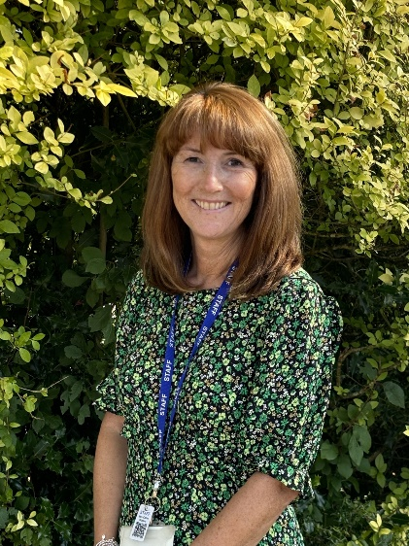

Contact Information
At Aberdare Town Church in Wales Primary School, we want you to feel free to approach us with any questions, queries, or comments you may have, and we encourage an open-door policy. There are a number of ways you can get in touch with us, and we welcome any response from parents, carers, or members of our community.
School Address
Aberdare Town Church in Wales Primary School,
Wind Street,
Aberdare.
CF447HF

Telephone
01685 871520
Email
admin@aberdaretownciwprimary.rctcbc.cymru



School Ethos and Values
At Aberdare Town Church in Wales Primary School, we pride ourselves on holding a Christian ethos, which underpins our pupils’ development through the curriculum and other activities. This ethos is sustained through a united effort to provide the very best for our pupils by striving to achieve a set of common aims.
At Aberdare Town Church in Wales Primary School we aim:
- To create an ethos of love, kindness and respect based upon our Christian faith
- To embed the "Rights of the Child" within the school;
- To provide caring and friendly surroundings where pupils will be happy and secure;
- To promote a healthy lifestyle;
- To create an ethos of high standards and expectations throughout the school;
- To give all our pupils access to a broad and balanced curriculum to enable them to fulfill their full potential;
- To provide high quality teaching and learning experiences to enable all children to achieve their full potential in all areas of the curriculum;
- To enable all pupils to develop a strong sense of self-worth, acquire a set of moral values and promote habits of self-discipline which will ensure high standards of good behaviour at all times;
- To provide experiences that will build pupils’ awareness of the spiritual dimension of life and to encourage them to respect other cultures, races, and religions;
- To develop independence in our pupils, to support them in becoming self-reliant and help them on the vital steps towards becoming lifelong learners;
- To provide pupils with the skills needed to communicate effectively and safely using a wide range of information systems, preparing them for the technological world of the future;
- To develop and promote pupils’ Welsh language skills, cultural awareness, and love of their Welsh heritage;
- To assist our pupils to become proactive global citizens;
- To develop a stimulating indoor and outdoor environment where pupils can learn by satisfying their own natural curiosity and individual interests;
- To ensure pupils are provided with a wide variety of first-hand experiences to enhance and supplement the curriculum;
- To secure a meaningful partnership between home, school and the wider community;
- To provide a programme of professional training to enable all staff to further develop their skills and knowledge

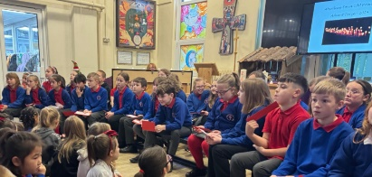
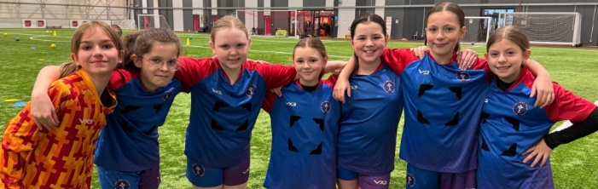

STAFFING
Head Teacher | Mrs. C. Walters
Deputy Head and PS1 Learning Co-ordinator | Mrs. R. Charles
ALN Co-ordinator and PS3 Learning Co-ordinator | Mrs. J. Palmer
Assessment and PS2 Learning Co-ordinator | Mrs. B. Hallam
Teaching Staff

Caterpillar Class | Mrs J Stone
Butterfly Class | Mrs E Wood
Ladybird Class | Mrs B Hallam and Mrs L Perkins
Dragonfly Class | Mrs R Charles
Hedgehog Class | Mrs A Reynolds
Squirrel Class | Mrs J Palmer
Fox Class | Mrs E Hamlin
Badger Class | Mrs E Manning
Owls Class | Miss D Hipkiss
H.L.T.A

Miss J Edmunds | Miss J Stone
L.S.A
#
P.S.1 | Mrs S Morgan  Mrs S Clarke  Mr B Weekes  Mrs K Meyrick
P.S.2 | Mrs D Driscoll  Miss C Perry
P.S.3 | Mrs B Samuels  Mrs A Pittard
School Clerk

Mrs. A Carter

Site Manager

Mr. P Richards
Lunchtime Supervisors

P.S. 1 & 2 | Mrs. K Meyrick  Mrs. D Driscoll  Mr. B Weekes
P.S. 3 | Mrs. A Pittard

At Aberdare Town Church in Wales Primary School, we have a Staff team who are hardworking and committed to ensuring that our pupils are provided with the best education possible.

GOVERNING BODY
Name | Term | Type
Mrs. Z Lummis | 04/12/28 | Foundation
Mr. A Lewis | 31/10/25 | Foundation
Mrs. M Morris | 23/10/26 | LEA
Mrs. J Gardiner | 30/01/27 | Foundation
Mrs. A Pittard | 05/03/28 | Staff
Mrs. L Hillman-King | 05/02/29 | Parent
Mrs. N Crowley | 12/10/28 | Foundation
Rev Peter Godsall | 27/02/29 | Foundation
Mrs. J Palmer | 30/09/28 | Staff
Mrs. C Walters |  | Headteacher

SCHOOL GROUNDS AND CLASSROOMS
Aberdare Town Church in Wales Primary School is a mix of an old stone-built school and a new modern building, occupying a site within the town of Aberdare. The school, which has very pleasant views, including playing fields and mountains, was opened in 1984 and serves a well-established town of Aberdare and the Cynon Valley in the County Borough of Rhondda Cynon Taff. The school also has relatively easy access to the A470. This school is a Primary School, which caters for pupils aged 3 to 11 years. The school building contains seven main teaching areas and an administrative area, housing the head teacher’s room, school office, and staff room. Our new block was refurbished in 2024 and houses 3 classrooms, a community room, and toilet. Our classrooms provide our pupils with fully equipped practical working areas. Each class has its own selection of reading and reference materials, a wide variety of learning resources, stationary and a range of IT equipment such as iPads, laptops, and class computers. The official means of entry to the school is accessed from Wind Street.

THE SCHOOL DAY
Progression Step 1 & 2 | 9:00 – 12:00 1:00 – 3:15
Progression Step 3 | 8:55 - 12:30 1:30 - 3:20

Breakfast Club starts at 8.00am every day. To begin the school day on time, pupils need to arrive by 8:50am. Our school gates open at 8:45am. Progression Step 1 & 2 enter through the Main Hall. Progression Step 3 enter via their classroom doors. If a pupil arrives after 9:00am, they should report to the school office, where they must be signed in by their parent/carer. They will then be escorted to their classroom. Pupils have a fifteen-minute break in the morning. Pupils have the option to bring a healthy snack with them to school, or a fruit tuck shop is available with healthy snacks that can be purchased. At the end of the school day, Progression Step 1 pupils are dismissed from the Nursery door, and the Imagination Station Doors. Progression Step 2 pupils are dismissed from the hall doors. Progression Step 3 pupils are dismissed from their classroom doors. Parents are asked to collect from the school yards.

SCHOOL TERM AND HOLIDAY DATES 2025/2026
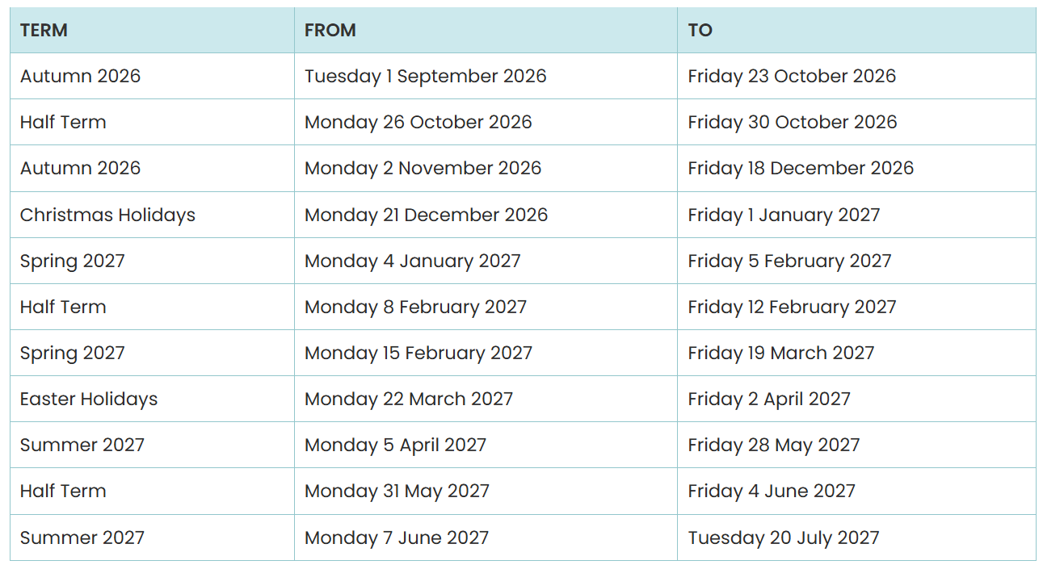

ADMISSIONS POLICY
Pupils are admitted into Aberdare Town Church in Wales Primary School in the September or January after their third birthday. Pupils may also be admitted into school at any point throughout the year if the class appropriate to their age has room. Parents who wish to send their children to Aberdare Town Church in Wales Primary School are sent an application form in the Spring Term for children starting school the following September. Parents are asked to return the form by a given date and if the number of places required does not exceed the given number for that class, then all children are offered a place.

Late Applications
Applications received after the deadline date will not be considered until offers have been made to those applications made before the deadline, and the parents/carers’ responses to these offers have been received. This means that if the school is over-subscribed and a late application fulfils a higher criterion than that under which places have been offered to other applicants, they will still be unsuccessful.
Appeals
Parents/carers that are not offered a place for their child have the right to appeal to an independent appeals committee under the Education Acts. The appeal will be considered by an independent Admission Appeal Panel, administered by the Llandaff Diocesan Board of Education, according to the Welsh Assembly Government‘s Code of Practice on School Admission Appeals.
Over Subscription Criteria
The Trust Deeds defines that the school was founded for the children in the Parish of Aberdare with approximately 37 in each class. Once our maximum number of 37 is reached, the Admissions Policy is administered using the following criteria: -
• ‘Looked After’ children or children with an Individual Development Plan, when the school is named as the most appropriate setting;
• Children who have a sibling who is a pupil registered at the school on the date when the applicant child is due to commence school (a sibling is defined as being a full or half-brother/sister, adopted or fostered);
• Children of practicing Christians or of other denominations;
• Children whose families wish them to be educated in a Church in Wales School. (Priority will be given to those living closest to the school, for whom Aberdare Town Church in Wales Primary is the closest Church school.
• Other children, at the discretion of the Governing Body, acting on the guidance of the National Society.
Application Forms
Admission application forms are available on request from the school. Details of the date they should be returned, late applications and the appeals process is in the full Admissions Policy. Parents of children due to attend in year groups other than Reception can apply at any time of year but should confirm that places are available before completing an application form. Parents are welcome to visit the school at any time but should make an appointment with the Head teacher to ensure it is convenient.
Open Days
Prospective parents moving into the area and considering sending their children to Aberdare Town Church in Wales Primary School are very welcome to make an appointment with the Head teacher, who will arrange a school tour. Much of the information from the prospectus, as well as details of the events and curriculum activities that take place in the school are also recorded on the school website. A gallery of photographs is available to view along with some of the school policies and documentation.
When a child is admitted into the school, the Governors expect them to participate fully in Religious Education and Collective Worship. However, parents can exercise their right of withdrawal from R.E. and Collective Worship.
Prospective parents moving to the area and considering sending their children to Aberdare Town Church in Wales Primary School are very welcome to make an appointment with the Head teacher, who will arrange a tour.

CHARGING & REMISSIONS
The school’s educational provision and most of the activities organised by the school are financed via funds received from Rhondda Cynon Taff Council. However, there are some valuable educational experiences that cannot be provided by the school without the financial support of the parents. Where school trips or visits to enrich the curriculum occur during school time, voluntary contributions to enable the visit to take place may be requested. The school will always strive to ensure that any funding requests are made in time to give parents the opportunity to spread the cost. If insufficient contributions are received, the school may be forced to cancel such activities.
A small charge may be requested for visiting workshops to support work being carried out in curriculum areas. No compulsory charge is made for materials used in school, except when pupils make products to take home. The Headteacher, in consultation with the Chair of Governors, can make remissions in any of the above areas.
The school holds fundraising events for local charities, national events, and global links. These are usually in the form of sponsored activities or special event days. Fundraising events may also be held for the school, such as curriculum-focused events. Parents’ contributions are always welcomed but not requested, and the children take part in all activities.

CURRICULUM
At Aberdare Town Church in Wales Primary School, the provision of a well-organised and stimulating curriculum catering for the needs of all is of paramount importance. Pupils may be placed in mixed or straight year groups. Staff will often teach to their expertise and may teach more than one class if appropriate.
Curriculum Content and Organisation
Children are taught in mixed ability classes according to their age. Children work most of their time in groups according to their stage of development, but within each class, teachers use a variety of teaching styles in order to maximise the learning experience. Relevant discussion between learners is encouraged, although some periods of the day are set aside for silent work, e.g., quiet reading time. The group system ensures that all children in a class may be catered for and that all learners are gainfully employed on programmes which relate directly to their individual ability and attainment levels. The size of classes varies every year and consequently support staff are assigned where most needed.
Learning Support Assistants are employed to assist children who have been identified as needing additional support and have been placed on the Additional Learning Needs Register. These children work in small groups both inside and outside the classroom.
Curriculum for Wales (CfW)
A new curriculum is being developed for settings and schools in Wales. Following a feedback period which ended in July 2019, the updated guidelines have been available from January 2022, which will be used throughout Wales from September 2022. Our school has been trialing our new curriculum throughout 2021-23. Pupils have been introduced to the Four Purposes, which are the basis of the CfW. The four purposes of the curriculum, as set out in Successful Futures, have guided the whole design and development of Curriculum for Wales 2022. They are the starting point for all decisions in respect of Curriculum for Wales 2022 and school-level curricula should be designed and guided by these same four purposes.
‘Curriculum’ includes all the learning experiences and assessment activities planned in pursuit of the four purposes of the curriculum, which are to develop children and young people as:
● ambitious, capable learners, ready to learn throughout their lives
● enterprising, creative contributors, ready to play a full part in life and work
● ethical, informed citizens of Wales and the world
● healthy, confident individuals, ready to lead fulfilling lives as valued members of society.
Curriculum for Wales 2022 is designed to help all learners realise these four purposes. Each purpose is more than a headline; it is also described in terms of key characteristics. In their entirety they should underpin all teaching and learning in Wales.’ -
https://hwb.gov.wales/draft-curriculum-for-wales-2022/a-guide-to-curriculum-for-wales –2022
Our Aberdare Town Church in Wales Primary School curriculum is based upon an inquiry approach. Our curriculum allows for pupils’ interests to be developed, often focusing in on our community and the rich Welsh Valleys heritage that surrounds us. It is also based upon our strong Christian values which permeate all we do.
Early Years Learning
Young children are active and learn through their senses. We offer opportunities for first-hand experiences and time for play and exploration. Through play, a child develops and strengthens the body, learns to play cooperatively, becomes independent and develops good relationships. A child learns to reason, compare, imagine, and draw conclusions. Play is the child’s work and their way of making sense of and finding out about the world around them. We believe that, for our children to be confident, happy and interested in life, their curriculum needs to be experienced rather than delivered.

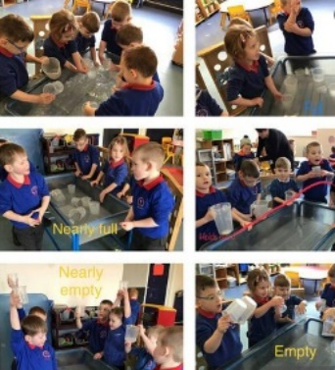
We have high expectations of all our pupils, recognising differing skills and abilities, and helping them to prepare for full and responsible lives. We ensure lessons are interactive, exciting and motivating for the children by organising educational visits, practical activities, visits from outside agencies and involvement with the local community.
We also promote ‘Values for Life’ throughout our curriculum and school ethos.
Religion Values and Ethics
Collective Worship is held each day, and children celebrate Worship in a range of different ways (e.g., Whole school Worship; class Worship and group Worship or spirituality time)
Father Robert Davies, Father Matthew and Reverend Peter conduct worship in school regularly and Celebration Services are held in St. Elvan’s Church Aberdare.
All the major church festivals are celebrated, with the services either held in the school hall or in a local church. Eucharist Services, to which parents and friends are warmly welcomed, may also be held in school or church. Under national legislation, parents have the right to withdraw their child from worship. Learning Support Assistants would be used to provide alternative study. However, it should be noted that the distinct Christian character of the school permeates all aspects of school life. Religious Education has been integrated as far as possible within class inquiries, and special festivals are celebrated in their own right. Religious Education teaching at Aberdare Town Church in Wales Primary School is based on the faith and practice of the Church-in-Wales. However, as our children live in a multicultural society, an element of comparative religion, encouraging a respect for other cultures and religions within our society is also built into the teaching.
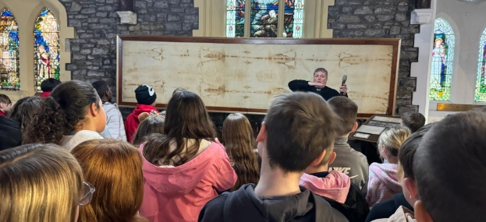

Development of the Welsh Language and Y Cwricwlwm Cymreig


Aberdare Town Church in Wales Primary School is a predominantly English medium primary school. All pupils in the Foundation Phase experience the areas of learning mainly through the medium of English. English is the main teaching medium at KS2.
Less than 20% of the teaching is through the medium of Welsh. The vast majority of children do not come from Welsh speaking backgrounds, but as Welsh is taught as a second language, the bilingualism of all children is developed with instructions in English & Welsh.
In addition to weekly Welsh lessons, pupils and staff use the Welsh language as much as possible around the school. We aim to give learners the opportunities to also develop and apply their knowledge and understanding of the cultural, economic, environmental, historical, and linguistic characteristics of Wales. Aberdare Town Church in Wales Primary School is very proud of our culture and heritage, and the school has won a national Heritage Award as well as being in receipt of the Gold Award in Siarter Iaith.

Health and Wellbeing
Extra-Curricular Activities
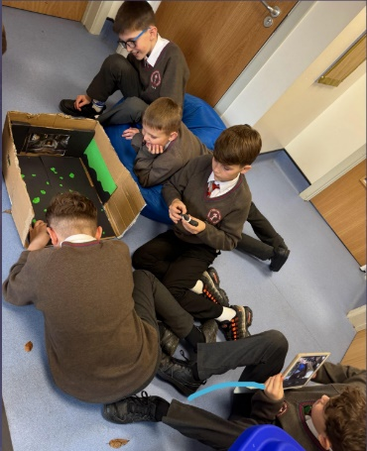
At Aberdare Town Church in Wales Primary School, we offer a wide variety of activities after school, including Choir, science club, dance, multi sports, Welsh, wellbeing, yoga, stay and play, story and craft club and coding club. Our school also has strong links with Cardiff City Football Club who undertake an after-school club in the Summer Term.
There is also the opportunity to become involved in and contribute to committees such as the School Senedd, Eco Committee, Criw Cymraeg, Worship Squad, Rights Respecting Rangers and Health and Wellbeing Ambassadors. These groups enrich the personal and social lives of the children and are always well received and attended. To further enhance the curriculum, the school provides the opportunity to visit a range of places of educational interest in the wider community.



Physical Education
Physical Education is an area of the curriculum which is important to children’s development. School sport and exercise is a high priority and pupils at Aberdare Town Church in Wales Primary School are given the opportunity to use their bodies effectively by encouraging spatial awareness, balance, control and coordination and by developing their gross and fine motor skills. They are able to explore and develop the essential physical skills for a variety of different activities. We address this through the curriculum and by developing PE and community links. The aim is to give children experience of a wide range of sporting and recreational activities. We also encourage competitive sports and the school has a successful football, rugby and netball team as well as talented athletes, gymnasts and dancers.
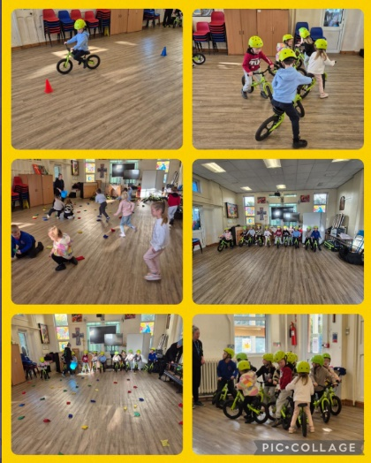
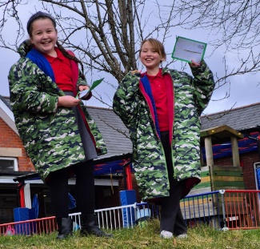
Outdoor Adventure activities are also an essential part of the PE curriculum. These activities are underpinned by problem solving, communication, leadership, and teamwork and often have an outdoor living and learning focus. Participation in outdoor activities provides opportunities to increase awareness of the natural environment and understand the importance of issues such as conservation and sustainable development. Year 6 pupils at school take part in a residential trip where outdoor adventurous activities are undertaken.
Pupils in Years 3 to 6 participate in swimming lessons at Aberdare Swimming Pool. Each year group has a weekly lesson for a whole term.
Relationships and Sexuality Education
The mandatory RSE Code supports schools to design their RSE curriculum. The content is set within the context of broad and interlinked learning strands, namely:
• relationships and identity
• sexual health and well-being
• empowerment, safety, and respect.
The RSE covers the following themes in RSE: relationships; rights and equity; sex, gender, and sexuality; bodies and body image; sexual health and well-being; and violence, safety, and support.
These themes are interwoven into the learning strands. Across the learning strands, curriculum content in RSE is inclusive and reflects diversity. It includes learning that develops learners’ awareness and understanding of different identities, views and values and a diversity of relationships, gender, and sexuality, including LGBTQ+ lives. Learning about rights and equity runs through all the strands, as well as embedding learning and experience through a rights-based approach to learning.
Our RSE curriculum is carefully designed to ensure that it is developmentally appropriate as learners’ needs of similar ages may differ. This means we take account of a range of factors including the learner’s age; knowledge and maturity; any additional learning needs and anticipating their physiological and emotional development. Our RSE curriculum is carefully designed to ensure that it is developmentally appropriate as learners’ needs of similar ages may differ.

Y Senedd (School Council)

Pupils from Nursery to Year 6 participate in School Council elections during each autumn term. A First Minister, Deputy Minister and Speaker are elected. Two representatives are also elected from each year group. The Senedd meets regularly and plays a direct role in the running of the school. The Senedd is an important feature of school life and allows children to take responsibility for, ownership of, and pride in their school.
Pupil Voice is an important part of our school family. There are various pupil voice groups which are valued by all. The groups encourage independence, responsibility, and shape our school by making decisions and knowing that their voices are heard.

Additional Learning Needs (ALN)
Aberdare Town Church in Wales Primary School takes great pride in helping all children reach their full potential. From those who need extra support for everyday learning, to those who are gifted in one or more areas and need this to be fostered and developed. Children who have ALN are given extra support according to their individual requirements. These additional needs may require support for long or short periods of time. The staff at the school work closely with parents to identify and meet the needs of these children.
Mrs. Palmer, the school ALNCo, works closely with staff and pupils as well as many outside agencies to ensure that the needs of all our pupils are met. Aberdare Town Church in Wales Primary School aspires to be fully inclusive – all reasonable adjustments are made to the environment and teaching and learning activities to ensure that children with disabilities are not disadvantaged. Any child admitted to the school with a disability will have access to support in line with the Local Education Authority policy. Details relating to individual children are discussed with parents prior to the child starting school, ensuring that the school can be fully prepared for the child. When there is continued concern about a child’s progress, additional advice and/or assessment may be requested from external agencies. Our policy is in line with the Special Needs Code of Practice for Wales on the identification and assessment of Special Educational Needs.
Pupils with disabilities
Children with disabilities are always welcomed at our school. We consult fully with parents and other agencies so that appropriate arrangements are made. A disability access survey has been undertaken to identify future development needs, and this has fed into our school accessibility plan.
Children who are Looked After
Children and young people become “Looked After” either if they have been taken into care by the local authority or if they have been accommodated by the local authority (a voluntary care arrangement). Most children who are looked after (CLA) will be living with foster parents, but a smaller number may be in children's residential units, living with a relative or even be placed at home with their birth parents.
The school is committed to providing quality education for all its pupils, based on equality of access, opportunity, and outcomes. The Designated Teacher, Mrs. Palmer, has been trained to ensure that all needs are met, including the use of Personal Education Plans (PEP) to promote educational achievement.
The designated teacher works in partnership with the social worker (who is responsible for initiating the PEP), pupil, carer, and any other person who may be relevant. It should be agreed upon within twenty school days of entering care or of joining our school and will normally be reviewed alongside the care plan. The PEP will identify specific areas of strengths and weaknesses and will include achievable targets. Areas to be included in the PEP are as follows;
- Attendance
- Achievement record (academic or otherwise)
- Behaviour
- Homework
- Involvement in extra-curricular activities
The Governing body will ensure that children who are looked after have the same right as everyone else in respect of:
• Admission to school
• The National Curriculum
• Extra-curricular activities
• Additional support with their education where needed

Equal Opportunities / Racial Equality
At Aberdare Town CiW Primary, we aim to create and maintain an environment presenting equal opportunities for each child. This is regularly monitored, and policies are updated according to a rolling programme.
Awareness of issues surrounding race, gender, culture, religion, and ALN are constantly raised. Positive steps are taken to ensure equal participation in the curriculum and to maintain respect for children's individual identity, culture, and heritage. Discrimination of any kind is unacceptable, and all staff strive to ensure that positive attitudes are fostered in every aspect of school life. Incidents of any kind are monitored, recorded, and reported.

Child Protection / Safeguarding
All staff agree that children's physical and emotional well-being is of paramount importance if they are to gain maximum benefit from the learning experiences offered. With regard to the protection of our children in this context, we aim:
• To create an atmosphere where children feel secure, are listened to and are valued.
• To recognise signs and symptoms of suspected abuse. • To devise clear procedures and lines of communication.
• To work closely with parents and other agencies.
• To use curriculum activities to build confidence and raise awareness. All staff are trained in identifying signs which may indicate a child protection issue. The Headteacher is the Designated Safeguarding Officer for the school, and the DHT and Mrs. Hallam are deputy safeguarding officers. Mrs. J Close is the Governor with responsibility for Safeguarding.
Illness or Accident
If a child is taken ill or injured in school, staff will contact parents as soon as possible. Parents are asked to give the school an emergency contact number and to ensure that the school is kept updated with any changes to names, addresses, or telephone numbers.
Parents should inform the school if a child has a serious or recurring medical problem. Children with long-term health problems, for example asthma or diabetes, can be treated by our trained staff once written consent has been provided. Staff regularly receive training to provide First Aid. Our First Aiders are Mrs. A Pittard and Miss J Robson. Children who have had a bout of sickness or diarrhoea should be kept at home for 48 hours.
Health Care
A routine medical questionnaire is completed on entry to the school and you will be notified of all arrangements for medical and dental inspections. Minor injuries are dealt with in school, but should your child receive any head injury or suspected breaks, then you will be contacted. It is important that we have contact telephone numbers in case of an emergency. If we are unable to reach you, then we will contact a doctor or arrange for a member of staff to take your child to hospital.
Head Lice
Children are not inspected for head infestation e.g. head lice. If the class teacher does observe head lice, we will contact you and encourage you to inspect your child’s hair and treat it if necessary. We rely on the close observation of the parents and immediate contact with us should anything be discovered. The more people who know, the quicker the problem can be solved, and the less likely it is that re-infestation will occur. It is important that you treat all members of your household on the same day; usually the treatment requires a follow-up two weeks later.

Administration of Medicines & Illness in School
Children who are unwell should not be sent to school, and those who suffer from sickness or diarrhoea should not return to school until 48 hours after these symptoms stop. Only prescribed medicines for long-term sufferers, which need to be taken during the school day, can be kept on the school premises. However, these cannot be administered by staff and must be taken independently by the pupil, whilst supervised by a member of staff. All medicines must be clearly labelled with the child's name, dosage, and time of administration. The expiry date must be clearly visible, and all liquids accompanied by the correct measuring spoon. Request forms for the administration of prescribed medicines must be completed.
- The medicine should not be kept by the pupil but given to a member of staff.
- The medicine should be self-administered, under the supervision of an adult.
- Children suffering from asthma must bring their inhalers to school. These inhalers should be clearly marked with the child's name and the dosage allowed.
- Parents should inform the school of any concerns regarding the health of their child, e.g., new inhalers for asthma sufferers, children newly diagnosed as asthmatic, any medical reason for withdrawing children from physical activity.

Secondary Transfer and Transition
At the age of eleven the majority of our children transfer to St John’s Church in Wales High School. Both Aberdare Town Church in Wales Primary School and St John’s share a transition plan to ensure the move from primary school to comprehensive is a smooth and happy one. Additional support is provided for those children identified as most anxious. If parents wish their child to transfer to a different secondary school, they may apply to the Local Education Authority. In the past, our children have transferred to a range of other local schools including Aberdare Community Comprehensive School and Mountain Ash Comprehensive School.

Pupil Data Protection
The school collects information about pupils and their parents/guardians at admission to school and for specific purposes during the year. Every effort is made to ensure the accuracy and security of the data collected, which is generally stored on the computerised school information management system. Parents have the right of access to information on pupil records and documents relating to the school's curriculum, on request to the Headteacher. Data policies are available on the school website.

Attendance and Family Holidays
Regular attendance and punctuality are essential if children are to gain maximum benefit from their time in school. All pupils should aim to achieve over 97% attendance. Parents should consider the implications on the education of their children if they take holidays during school time. Such absence may incur a Fixed Penalty Notice. (School does not currently issue fines)
Research has shown that taking 10 days’ absence every academic year of a child’s lifetime adds up to nearly a full year of a child’s education missed. The school will refer any prolonged or repeated periods of absence or persistent lateness to the Attendance Welfare Officer.
Attendance protocols at Aberdare Town Church in Wales Primary School:
- If your child/ren will not be attending school, you must ring the school and notify them. Please DO NOT send messages to class teachers on dojo.
- School starts at 8:55 for our older pupils in P.S. 3 and 9;00 for pupils in P.S. 1 & 2. All children must try to be in school on time. If they are constantly late, they are missing important learning time which can affect their progress in School.
- Holidays forms must be submitted to the school 4 weeks before a holiday.
- Appointments during school time must be confirmed by appointment card, letter or by showing a text message.

Eating at School
School Meals and Dinners
School meals are cooked on the premises, and the menus are carefully planned by the local authority to ensure a balanced diet over a two-week period. Menus are available each term to inform parents of the range of meals being provided by the school meals service. Alternatively, children may bring a healthy packed lunch, if they wish.
In the interests of safety, no cans or glass containers should be included. As a Healthy School, we discourage crisps and sweets, preferring vegetable and fruit options.
Advice regarding eligibility for free school meals is available from the school office. If your child suffers from a food allergy, or requires vegetarian options, it is essential that you let us know so that our catering services will offer an appropriate menu.
Assessment and Reporting to Parents
Pupils from Year 2 to 6 are tested twice a year in Numeracy, Numerical Reasoning, and Reading. The results of these tests are shared with parents in a way that compares their child’s performance to others nationally. These procedures assist pupils to know where they are in terms of strengths and weaknesses and to know what action needs to be taken to progress further. They also inform all sections of the community, primarily teachers, parents, and governors, of pupils’ progress.
The school values its excellent relationship with parents. Parents are always welcome to discuss any matter affecting the child’s welfare or progress, and we are very proud of our open-door policy. We hold two consultations during the academic year. The first takes place in the Autumn Term. The second, in the Spring Term, is when parents are given the opportunity to see their child’s work and discuss progress with the class teacher. Reports are sent home at the end of the summer. Although there is no formal consultation, parents are able to comment and book an appointment to see their class teacher.
Pupils’ skills in Literacy and Numeracy are outlined for each year group and progress against these is carefully monitored. All pupils’ Literacy and Numeracy skills are tracked, and these too are reported back to parents via an annual report.
Reports are also sent to parents upon entry into the school. This is in the form of a written report within a period of 6 weeks of your child starting at our school. This report will contain information regarding your child’s attainment in Literacy, Numeracy and Wellbeing and will give information regarding next steps in their learning and how they can be supported.
Home-School Agreement
This sets out in simple terms the expectations we have of our children and parents, and what parents and children can expect from Aberdare Town Church in Wales Primary School. It has been developed to raise standards and contribute to school effectiveness by enhancing partnerships between parents, children, and the school.
Parental Involvement
We actively encourage parental involvement at Aberdare Town Church in Wales Primary School. If any parents have a particular area of expertise, or would simply enjoy helping out at school, please contact Mrs. Walters, Head teacher.
All parent helpers are required to have a DBS check and complete a brief application. These are available from Mrs. McGinn in the school office. As a school family, we are committed to Family Learning, and we have begun a series of family workshops which are intended to allow family members to work with their children and find out about the curriculum in school.
The school arranges numerous fundraising activities throughout the year and raises money for school funds. In addition, our Friends Association encourages close links between the staff, parents, local residents, churches, and other members of our community who are associated with the school. New parents are always welcome, and their support is much appreciated.
Homework
Homework consolidates and reinforces learning. It also provides parents with a fuller awareness of the skills and learning strategies that their child is covering in school. It helps to develop the habits of independent study. Pupils have sounds/spellings to learn weekly. Regular reading practice is encouraged to ensure that even fluent readers attain the advanced reading skills needed to develop independent learning. Younger pupils are provided with a reading record diary and homework books which can be used to communicate comments regarding the child’s progress, between the teacher and the pupil.
Discipline through Positive Behaviour Strategies
In order to provide a safe and secure environment, good standards of behaviour are essential. Positive behaviour management strategies are used to foster responsibility for pupils’ actions, choices, and behaviours and to encourage and develop mutual respect. A high standard of behaviour is expected of all children, both in and out of school, based on the principle of courtesy and consideration for others.
Our staff team believes that effective management of behaviour is best facilitated using positive strategies which value achievement and offer praise and encouragement. Consistent attitudes, age-appropriate expectations and methods are crucial for staff to help children develop kind, considerate, and positive behaviours.
Certificates and stickers are awarded for behaviour, courtesy, random acts of kindness, and care of the environment, as well as academic and sporting achievement. The school holds a weekly celebration worship to celebrate the children’s achievements.
It is accepted that children who have acquired high self-esteem and self-confidence are likely to achieve well and interact as cooperative, responsible and reliable members of a group. Repeated unacceptable behaviour might necessitate a short period of withdrawal. The child will be expected to sit apart from the activity or the group and to reflect on the occurrence, or the withdrawal of other privileges such as break time.
Pupils who continue to engage in such behaviour are sent to the head teacher. The child’s parent is consulted to ensure consistent management in both the home and school settings. Parents are also involved in the school’s programme of management and, if necessary, are helped towards suitable targets to aim for at home.

Bullying
Young school children may sometimes present a form of intimidating and threatening behaviour towards their peers, which might ultimately become serious bullying at a later stage of schooling. Staff are alert to this. Staff also respond promptly to concerns expressed by a parent.
It is made clear to all concerned that such behaviour cannot be accepted. Suitable sanctions, or modification of the unwanted behaviour, will be initiated. Incidents of this kind of behaviour are monitored, recorded, and reported.
Aberdare Town Church in Wales Primary School is fortunate to have few incidents, as a result of the professionalism, dedication, and vigilance of staff. However, even one such incident is a serious breach of the school rules. The anti-bullying policy was devised in conjunction with the school council, and several pupil-led initiatives have been very successful in discouraging bullying and maintaining good behaviour.

Complaints Procedures
There may be an occasion when something happens in school that you are not happy about. Our complaints procedure is a way of ensuring that anyone with an interest in the school can raise a concern, with confidence that it will be listened to and, if well founded, dealt with in an appropriate and timely fashion. Sometimes you might be concerned about matters that are not decided by the school, in which case we will tell you to whom you should complain.
Informal Concerns
Most concerns can be settled quickly just by speaking to the relevant person in school, without the need to use a formal procedure:
Generally, the member of staff involved should be parents’ initial contact. Complaints should be brought to the attention of the school as soon as possible - within 10 school days.
If it is not possible to resolve the matter in this way, the Head teacher should be approached within 5 days of receiving a response to your concern.
Formal Concerns
Complaints should then be passed in writing to the Headteacher. If it is not possible to resolve the matter in this way, the complaint should be addressed to the Chair of Governors.
The following is a summary of our full complaints procedure. Full details of the procedure may be obtained from the School Office or from the Clerk to the Governing Body:
Complaints should be brought to the attention of the school as soon as possible. Any matters raised more than 3 months after the event will not be considered, save in exceptional circumstances. A log will be kept of all complaints and is retained for seven years. Your complaint will be dealt with fairly and impartially, and as quickly and effectively as possible – within 10 school days of receipt of the same, save in exceptional circumstances.
Your complaint will be kept confidential, with only those involved in investigating and making a decision being aware of the details of the complaint. It is likely, however, that the person who is being complained about will be told of the complaint. You will be kept informed of progress throughout the process. All anonymous complaints will be recorded and may only be investigated if there are exceptional circumstances.

School Uniform
A uniform contributes to a sense of belonging to the school community and generates a feeling of pride at Aberdare Town Church in Wales Primary School.
Nursery – Year 5
Blue round neck sweatshirt/hoodie/cardigan. Red or white polo style shirt. Black/grey trousers (warm weather alternative – red/white polo style shirt with black/grey shorts or a blue gingham dress). Black shoes.
Year 6
White shirt, grey jumper or cardigan, tie, grey trousers or skirt (warm weather alternative – white short sleeved shirt, tie with black/grey shorts). Black shoes.


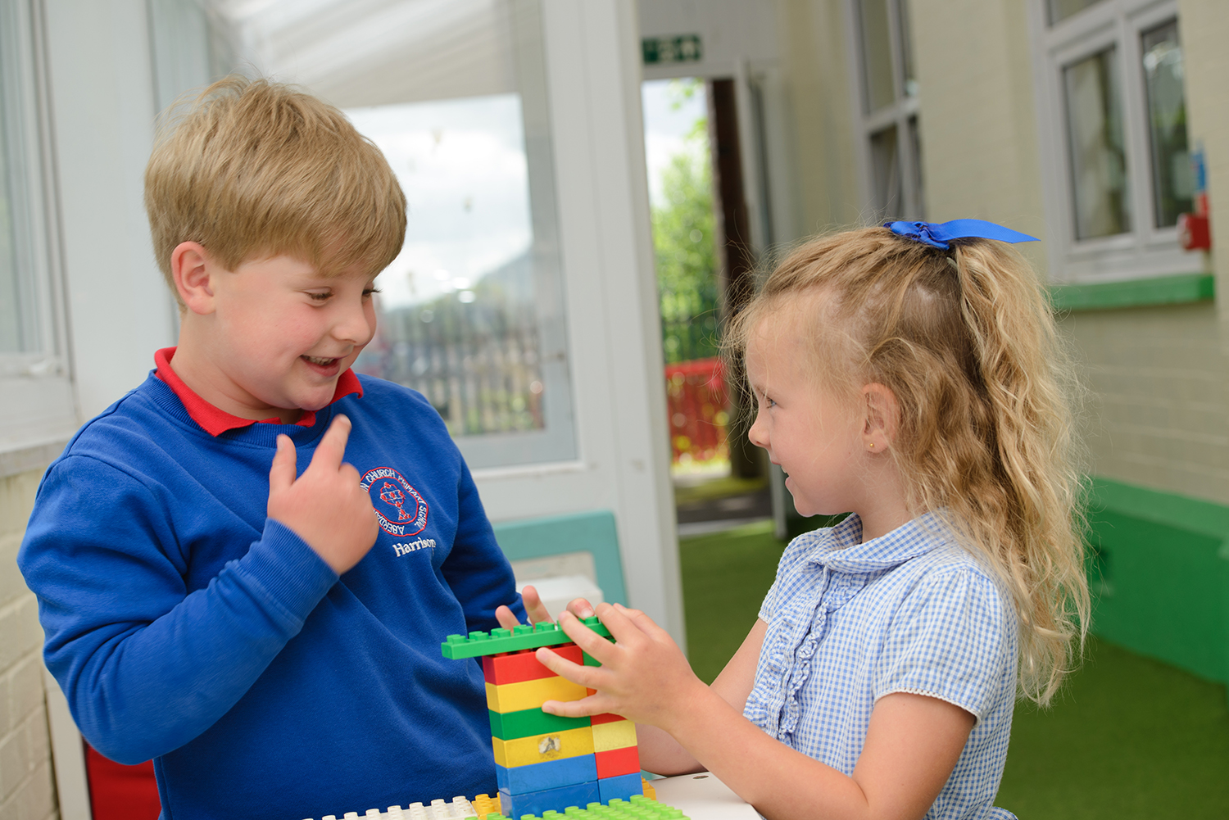
P.E. Kit
For health and safety reasons, we advise that children wear appropriate clothing for their physical education lessons. While much indoor work will be done with bare feet, gym shoes or trainers should be provided for outside. Black shorts/joggers and a plain white T-shirt are encouraged.
Jewellery
The wearing of jewellery, including earrings, is not allowed. For safety reasons, necklaces and bracelets should not be worn as they can catch on clothes or other children and cause serious injury.
Hair
Children with long hair are encouraged to keep it tied back for school, but it must be tied back for all physical activities to avoid it becoming caught or entangled.
If parents would like to purchase items of clothing with the school logo, these are available from DYST. Parents can also purchase school uniform from Asda, Tesco, Matalan etc. and you have the option to take them to the above shops for logo embroidery although this is not a requirement.
Please ensure that all items of clothing and footwear are clearly labelled with your child's name.

Thank you for your interest in our school. Please do not hesitate to contact us to arrange an appointment to visit or to find out more. We look forward to welcoming you to the family of Aberdare Town Church in Wales Primary.

